Palm Sunday of the Lord's Passion
ACT 1: Jesus Enters Jerusalem - Gospel Mt 21:1-11

Cloaks or shawls
Colt (a stick?)
Palm branches (can be made from newspaper)
A city sign for Jerusalem

Mark out a road to Jerusalem include the sign
Give palms to crowd 1
Give cloaks to disciples
Place colt a bit before the beginning of the road

NARRATOR
OT NARRATOR
JESUS
DISCIPLE PHILIP
DISCIPLE NATHANIEL
Divide rest of class between crowd 1 and crowd 2

NARRATOR: When Jesus and the disciples drew near Jerusalem and came to Bethphage on the Mount of Olives, Jesus sent two disciples, saying to them,
JESUS: “Go into the village opposite you,
and immediately you will find an ass tethered,
and a colt with her. Untie them and bring them here to me. And if anyone should say anything to you, reply, ‘The master has need of them.’
Then he will send them at once.”
NARRATOR: This happened so that what had been spoken through the prophet might be fulfilled:
OT NARRATOR: Say to daughter Zion, “Behold, your king comes to you, meek and riding on an ass, and on a colt, the foal of a beast of burden.”

NARRATOR: The disciples went and did as Jesus had ordered them. They brought the ass and the colt and laid their cloaks over them, and he sat upon them.

ACTION: (Disciples Philip and Nathaniel bring the colt and put “cloaks” on it and Jesus rides it.)
NARRATOR: The very large crowd spread their cloaks on the road, while others cut branches from the trees and strewed them on the road. The crowds preceding him and those following kept crying out and saying:

ACTION: (Jesus rides the colt slowly along the road up to the Jerusalem sign. Crowd 1 starts out as a line along the road. They spread the Palms ahead of Jesus, watch him pass, then follow saying the following all together..)
CROWD 1: “Hosanna to the Son of David;
blessed is he who comes in the name of the Lord, hosanna in the highest.”
ACTION: (Crowd 2 is lined up along the road on the Jerusalem side of the sign. As Jesus comes into Jerusalem with Crowd 1 following, Crowd 1 stops talking and crowd 2 speaks.)

NARRATOR: And when he entered Jerusalem
the whole city was shaken and asked,

CROWD 2: “Who is this?”
CROWD 1: “This is Jesus the prophet, from Nazareth in Galilee.”

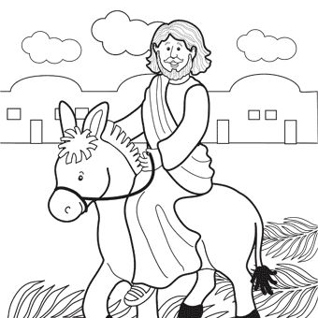

ACT 2: The Last Supper - Gospel mt 26:14-27:66

Coins
Cup
Bread-1 tortilla
Plate
tablecloth

Judas and Chief Priest together in spot on left.
Jesus and disciples are together in center.
Table and House Owner and at the right.

NARRATOR
CHIEF PRIEST
JUDAS ISCARIOT
JESUS
DISCIPLE ANDREW
DISCIPLE PETER
DISCIPLE JAMES
DISCIPLE JOHN
DISCIPLE MATTHEW
HOUSE OWNER

ACTION: (Judas and the Chief Priest are standing together off to the side.)

NARRATOR: One of the Twelve, who was called Judas Iscariot, went to the chief priests and said,
JUDAS: “What are you willing to give me if I hand him over to you?”

ACTION: (The Chief Priest gives Judas some coins.)
NARRATOR: They paid him thirty pieces of silver, and from that time on he looked for an opportunity to hand him over.
--- * ---
ACTION: (Scene changes to Jesus and Disciples. Judas goes over to Jesus.)
NARRATOR: On the first day of the Feast of Unleavened Bread, the disciples approached Jesus and said,
DISCIPLE ANDREW: “Where do you want us to prepare for you to eat the Passover?”
JESUS: “Go into the city to a certain man and tell him, ‘The teacher says, “My appointed time draws near; in your house I shall celebrate the Passover with my disciples.”’”
ACTION: (The disciples go to table and pretend to talk to house owner. Then they pretend to be cooking. They take out the tablecloth and put it on the table and put the cup, plate and tortilla on the table.)

NARRATOR: The disciples then did as Jesus had ordered, and prepared the Passover.
NARRATOR: When it was evening, he reclined at table with the Twelve.

ACTION: (Jesus comes to the table and sits down.)
JESUS: “Amen, I say to you, one of you will betray me.”

ACTION: (Disciples look worried. Turn to Jesus and say.)

DISCIPLES: “Surely it is not I, Lord?”
ACTION: (Judas reaches for Jesus plate and takes a piece of tortilla.)
JESUS: “He who has dipped his hand into the dish with me is the one who will betray me. The Son of Man indeed goes, as it is written of him, but woe to that man by whom the Son of Man is betrayed.
It would be better for that man if he had never been born.”

JUDAS: “Surely it is not I, Rabbi?”
JESUS: “You have said so.”
ACTION: (Judas leaves. All watch as Jesus does the actions as the narrator describe them.)

NARRATOR: While they were eating, Jesus took bread, said the blessing, broke it, and giving it to his disciples said,
JESUS: “Take and eat; this is my body.”
NARRATOR: Then he took a cup, gave thanks, and gave it to them, saying,
JESUS: “Drink from it, all of you, for this is my blood of the covenant, which will be shed on behalf of many for the forgiveness of sins. I tell you, from now on I shall not drink this fruit of the vine until the day when I drink it with you new in the kingdom of my Father.”
JESUS: “This night all of you will have your faith in me shaken, for it is written:
I will strike the shepherd, and the sheep of the flock will be dispersed;
but after I have been raised up, I shall go before you to Galilee.”

DISCIPLE PETER: “Though all may have their faith in you shaken, mine will never be.”
JESUS: “Amen, I say to you, this very night before the cock crows, you will deny me three times.”
DISCIPLE PETER: “Even though I should have to die with you, I will not deny you.”
NARRATOR: And all the disciples spoke likewise.

NARRATOR: Then, after singing a hymn,
they went out to the Mount of Olives.

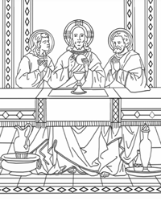
ACT 3: The Garden of Gethsemane

Sword
Red ribbon

NARRATOR
JESUS
DISCIPLE PETER
DISCIPLE JAMES
DISCIPLE JOHN
JUDAS
LEADER OF CROWD
CROWD
HIGH PRIEST’S SERVANT

ACTION: (Jesus, Peter, James and John walk onto stage.)

NARRATOR: Then Jesus came with them to a place called Gethsemane. He took along Peter and the two sons of Zebedee, and began to feel sorrow and distress.
JESUS (to PETER, JAMES, JOHN): “Sit here while I go over there and pray.” “My soul is sorrowful even to death.”

NARRATOR: He advanced a little and fell prostrate in prayer, saying,
ACTION: (Jesus goes a little way away from the disciples, lays on the ground, and prays.)

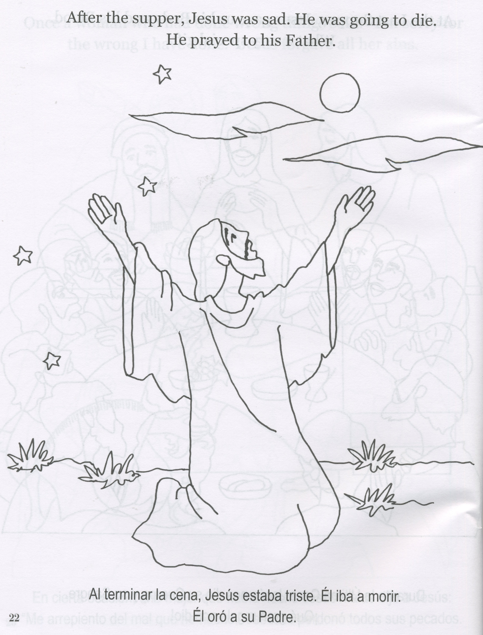

JESUS: “My Father, if it is possible, let this cup pass from me; yet, not as I will, but as you will.”
NARRATOR: When he returned to his disciples he found them asleep.
JESUS: (to Peter) “So you could not keep watch with me for one hour? Watch and pray that you may not undergo the test. The spirit is willing, but the flesh is weak.”
NARRATOR: Withdrawing a second time, he prayed again,
JESUS: “My Father, if it is not possible that this cup pass without my drinking it, your will be done!”
NARRATOR: Then he returned once more and found them asleep, for they could not keep their eyes open. He left them and withdrew again and prayed a third time, saying the same thing again.
JESUS: “My Father, if it is not possible that this cup pass without my drinking it, your will be done!”
NARRATOR: Then he returned to his disciples and said to them,
JESUS: “Are you still sleeping and taking your rest? Behold, the hour is at hand when the Son of Man is to be handed over to sinners. Get up, let us go. Look, my betrayer is at hand.”
NARRATOR: While he was still speaking,
Judas, one of the Twelve, arrived, accompanied by a large crowd, with swords and clubs, who had come from the chief priests and the elders
of the people. His betrayer had arranged a sign with them, saying,
JUDAS to LEADER OF CROWD: “The man I shall kiss is the one; arrest him.”
ACTION: (Judas goes over to Jesus.)
JUDAS to JESUS: “Hail, Rabbi!”

ACTION: (Judas gives Jesus an “air kiss”.)

JESUS: “Friend, do what you have come for.”
NARRATOR: Then stepping forward they laid hands on Jesus and arrested him. And behold, one of those who accompanied Jesus put his hand to his sword, drew it, and struck the high priest’s servant, cutting off his ear.
ACTION: (Peter swings the sword at the servant who grabs his ear, letting one end of a red ribbon that was in his hand fall.)

JESUS: “Put your sword back into its sheath,
for all who take the sword will perish by the sword.
Do you think that I cannot call upon my Father
and he will not provide me at this moment
with more than twelve legions of angels?
But then how would the Scriptures be fulfilled
which say that it must come to pass in this way?”

ACTION: (Jesus heals the servant, taking away the red ribbon.)
JESUS to ALL: “Have you come out as against a robber, with swords and clubs to seize me? Day after day I sat teaching in the temple area, yet you did not arrest me. But all this has come to pass
that the writings of the prophets may be fulfilled.”
NARRATOR: Then all the disciples left him and fled.

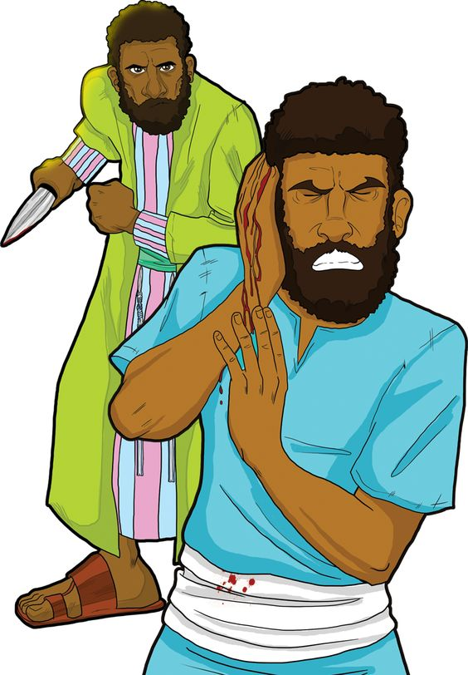

ACT 4: Jesus is Arrested

Picture of a rooster

To the right is a place where Peter will sit.
To the left is Caiaphas, the crowd and Jesus.
Others and girl stand in the middle but back.
Rooster Holder is where Peter started.

NARRATOR
PETER
WITNESS 1
WITNESS 2
CAIAPHAS, THE HIGH PRIEST
JESUS
MAID
CROWD
GIRL
OTHERS
BYSTANDER
ROOSTER HOLDER

NARRATOR: Those who had arrested Jesus led him away to Caiaphas the high priest, where the scribes and the elders were assembled. Peter was following him at a distance as far as the high priest’s courtyard, and going inside he sat down with the servants to see the outcome.

ACTION: (Peter goes to a pre-defined place and sits.) (CAIAPHAS sits in his chair.)

---- * -----
NARRATOR: The chief priests and the entire Sanhedrin kept trying to obtain false testimony against Jesus in order to put him to death, but they found none, though many false witnesses came forward. Finally two came forward who stated,

ACTION: (WITNESSES come to CAIPHAS)

WITNESSES: “This man said, ‘I can destroy the temple of God and within three days rebuild it.’”
CAIAPHAS to JESUS: Have you no answer?
What are these men testifying against you?”
NARRATOR: But Jesus was silent. Then the high priest said to him,
CAIAPHAS to JESUS: “I order you to tell us under oath before the living God whether you are the Christ, the Son of God.”

JESUS: “You have said so. But I tell you: From now on you will see ‘the Son of Man seated at the right hand of the Power’ and ‘coming on the clouds of heaven.’”
ACTION: (High Priest messes up his clothes.)
CAIAPHAS: “He has blasphemed! What further need have we of witnesses? You have now heard the blasphemy; what is your opinion?”
CROWD: “He deserves to die!”
ACTION: (Crowd pretends to hit Jesus and pretend to spit at him.)

CROWD to JESUS: “Prophesy for us, Christ: who is it that struck you?”

ACTION: (Crowd stops doing everything. Focus changes to Peter.)

----- * -----
NARRATOR: Now Peter was sitting outside in the courtyard. One of the maids came over to him and said,
MAID to PETER: “You too were with Jesus the Galilean.”
PETER: “I do not know what you are talking about!” (Peter gets up and goes by OTHERS.)
GIRL to OTHERS: “This man was with Jesus the Nazorean.”
PETER: “I do not know the man!”
ACTION: (Bystander comes over.)
BYSTANDER: “Surely you, too, are one of them;
even your speech gives you away.”
PETER (angrily): “I do not know the man.”
NARRATOR: And immediately a cock crowed.

ACTION: (ROOSTER HOLDER Raises rooster image and crows.)
NARRATOR: Then Peter remembered the words that Jesus had spoken:
JESUS (from off stage): “Before the cock crows you will deny me three times.”
ACTION: (PETER walks off stage, weeping.)


ACT 5: Jesus is Condemned

Bag of coins
Bowl of water
Red ribbons
Crown of thorns
Reed or thin stick

Scene opens with Judas talking to the Chief Priest.
Second scene Pilate walks to his chair and sits and Jesus is led to him by a soldier.

NARRATOR
JUDAS
CHIEF PRIEST
PILATE
JESUS
BARABBAS
CROWD
SOLDIERS
PILATE’S WIFE

NARRATOR: When it was morning, all the chief priests and the elders of the people took counsel against Jesus to put him to death. They bound him, led him away, and handed him over to Pilate, the governor.
NARRATOR: Then Judas, his betrayer, seeing that Jesus had been condemned, deeply regretted what he had done. He returned the thirty pieces of silver
to the chief priests and elders’.
JUDAS to CHIEF PRIEST: “I have sinned in betraying innocent blood.”
CHIEF PRIEST: “What is that to us? Look to it yourself.”
ACTION: (Judas flings the money into the temple,
goes to left of stage and hangs himself.)
ACTION: (Chief priest gathers up the money.)

CHIEF PRIEST: “It is not lawful to deposit this in the temple treasury, for it is the price of blood.”
NARRATOR: After consultation, they used the money to buy the potter’s field as a burial place for foreigners. That is why that field even today is called the Field of Blood. Then was fulfilled what had been said through Jeremiah the prophet,
OT NARRATOR: And they took the thirty pieces of silver, the value of a man with a price on his head, a price set by some of the Israelites,
and they paid it out for the potter’s field
just as the Lord had commanded me.
---- * -----

ACTION: (Change scene to where Jesus is standing in front of Pilate.)

NARRATOR: Now Jesus stood before the governor, and he questioned him.
PILATE: “Are you the king of the Jews?”
JESUS: “You say so.”
NARRATOR: And when he was accused by the chief priests and elders, he made no answer.
PILATE: “Do you not hear how many things they are testifying against you?”
NARRATOR: But he did not answer him one word, so that the governor was greatly amazed.
While he was still seated on the bench, his wife sent him a message,

PILATE’S WIFE: “Have nothing to do with that righteous man. I suffered much in a dream today because of him.”
NARRATOR: Now on the occasion of the feast the governor was accustomed to release to the crowd one prisoner whom they wished. And at that time they had a notorious prisoner called Barabbas. So when they had assembled, Pilate said to them,
PILATE: “Which one do you want me to release to you, Barabbas, or Jesus called Christ?”
NARRATOR: For he knew that it was out of envy
that they had handed him over. The chief priests and the elders persuaded the crowds to ask for Barabbas and to destroy Jesus.
PILATE: “Which of the two do you want me to release to you?”
CROWD: “Barabbas!”
PILATE: “Then what shall I do with Jesus called Christ?”
CROWD: “Let him be crucified!”
PILATE: “Why? What evil has he done?”
CROWD (louder): “Let him be crucified!”
NARRATOR: When Pilate saw that he was not succeeding at all, but that a riot was breaking out instead, he took water and washed his hands in the sight of the crowd.

PILATE: “I am innocent of this man’s blood.
Look to it yourselves.”
CROWD: “His blood be upon us and upon our children.”

ACTION: (Barabbas goes into the crowd who are happy to see him. Jesus goes the other direction a few steps with the soldiers, who whip him with red ribbons.)
NARRATOR: Then he released Barabbas to them,
but after he had Jesus scourged, he handed him over to be crucified. Then the soldiers of the governor took Jesus inside the praetorium and gathered the whole cohort around him.

ACTION: (Soldiers do all listed in the next paragraphs as it is read.)
NARRATOR: They stripped off his clothes and threw a scarlet military cloak about him. Weaving a crown out of thorns, they placed it on his head, and a reed in his right hand. And kneeling before him, they mocked him, saying,
SOLDIERS: “Hail, King of the Jews!”
NARRATOR: They spat upon him and took the reed and kept striking him on the head. And when they had mocked him, they stripped him of the cloak, dressed him in his own clothes, and led him off to crucify him.

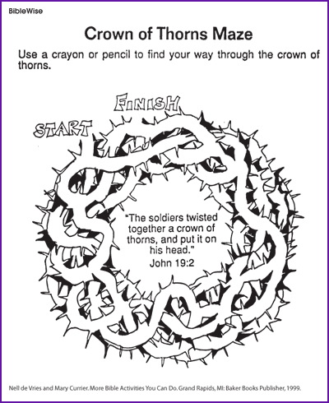

ACT 6: Jesus is Crucified

Cup
Dice
A shirt
INRI sign
Sponge
cloth

NARRATOR
JESUS
SIMON
SOLDIERS
REVOLUTIONARY 1
REVOLUTIONARY 2
PASSERBY 1
PASSERBY 2
BYSTANDER
CHIEF PRIEST
CENTURION
3 MARYs
JOSEPH OF ARIMATHEA

NARRATOR: As they were going out, they met a Cyrenian named Simon; this man they pressed into service to carry his cross.
NARRATOR: And when they came to a place called Golgotha ¬—which means Place of the Skull —, they gave Jesus wine to drink mixed with gall.
But when he had tasted it, he refused to drink. After they had crucified him, they divided his garments by casting lots; then they sat down and kept watch over him there. And they placed over his head the written charge against him:
This is Jesus, the King of the Jews.
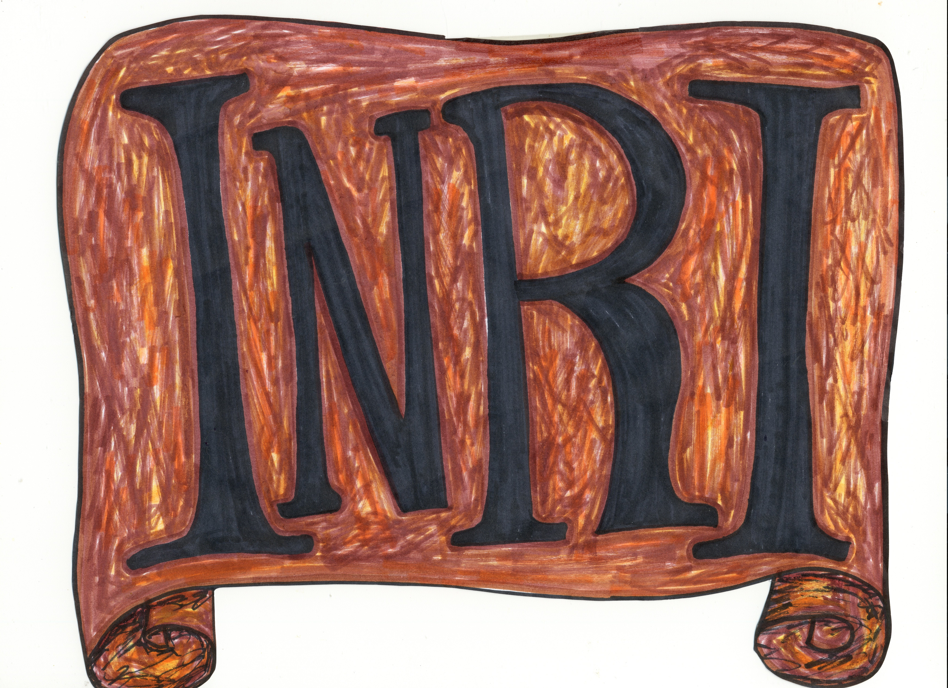
NARRATOR: Two revolutionaries were crucified with him, one on his right and the other on his left.
Those passing by reviled him, shaking their heads and saying,
PASSERBY 1: “You who would destroy the temple and rebuild it in three days, save yourself, if you are the Son of God, and come down from the cross!”
NARRATOR: Likewise the chief priests with the scribes and elders mocked him.
CHIEF PRIEST: “He saved others; he cannot save himself. So he is the king of Israel! Let him come down from the cross now, and we will believe in him. He trusted in God; let him deliver him now if he wants him. For he said, ‘I am the Son of God.’”
NARRATOR: The revolutionaries who were crucified with him also kept abusing him in the same way.
NARRATOR: From noon onward, darkness came over the whole land until three in the afternoon. And about three o’clock Jesus cried out in a loud voice,
JESUS: “Eli, Eli, lema sabachthani?”
NARRATOR: which means,

JESUS: “My God, my God, why have you forsaken me?”
BYSTANDER: “This one is calling for Elijah.”
NARRATOR: Immediately one of them ran to get a sponge; he soaked it in wine, and putting it on a reed, gave it to him to drink.
PASSERBY 2: “Wait, let us see if Elijah comes to save him.”
NARRATOR: But Jesus cried out again in a loud voice, and gave up his spirit.
Here all kneel and pause for a short time.
NARRATOR: And behold, the veil of the sanctuary was torn in two from top to bottom.
The earth quaked, rocks were split, tombs were opened, and the bodies of many saints who had fallen asleep were raised. And coming forth from their tombs after his resurrection, they entered the holy city and appeared to many.
NARRATOR: The centurion and the men with him who were keeping watch over Jesus feared greatly when they saw the earthquake and all that was happening, and they said,
CENTURION: “Truly, this was the Son of God!”
NARRATOR: There were many women there, looking on from a distance, who had followed Jesus from Galilee, ministering to him. Among them were Mary Magdalene and Mary the mother of James and Joseph, and the mother of the sons of Zebedee.
ACTION: (Joseph of Arimathea goes to where Pilate is sitting and pretends to talk to him. Pilate nods.)
NARRATOR: When it was evening, there came a rich man from Arimathea named Joseph, who was himself a disciple of Jesus. He went to Pilate and asked for the body of Jesus; then Pilate ordered it to be handed over.

ACTION: (As the narrator reads, do the actions. Use a tabletop as the tomb. )

Taking the body, Joseph wrapped it in clean linen and laid it in his new tomb that he had hewn in the rock. Then he rolled a huge stone across the entrance to the tomb and departed.
But Mary Magdalene and the other Mary remained sitting there, facing the tomb.
NARRATOR: The next day, the one following the day of preparation, the chief priests and the Pharisees gathered before Pilate and said,
CHIEF PRIEST: “Sir, we remember that this impostor while still alive said, ‘After three days I will be raised up.’ Give orders, then, that the grave be secured until the third day, lest his disciples come and steal him and say to the people,
‘He has been raised from the dead.’
This last imposture would be worse than the first.”
PILATE: “The guard is yours; go, secure it as best you can.”

ACTION: (Soldiers march to the tomb and stand guard.)
NARRATOR: So they went and secured the tomb

